cnc_rdzofs

声明
/* read work zero offset value */
[DllImport("FWLIB32.dll", EntryPoint = "cnc_rdzofs")]
public static extern short cnc_rdzofs(ushort FlibHndl,short a, short b, short c, [Out, MarshalAs(UnmanagedType.LPStruct)] IODBZOFS d);

描述
读工件坐标偏移。

参数
（1）FlibHndl 库句柄；[ in ]
（2）number 设置工件坐标偏移号；[ in ]
（3）axis 设置工件坐标偏移轴； [ in ]
（3）zofsr； [ out ]
/* cnc_rdzofs:read work zero offset value */
/* cnc_wrzofs:write work zero offset value */
[StructLayout(LayoutKind.Sequential, Pack = 4)]
public class IODBZOFS
{
public short datano; /* offset NO. */
public short type; /* axis number */
[MarshalAs(UnmanagedType.ByValArray, SizeConst = MAX_AXIS)]
public int[] data = new int[MAX_AXIS]; /* data value */
}

函数返回值
函数运行正常返回EW_OK。
Return code | Meaning/Error handling
EW_LENGTH  (2) | Data block length error  Size of IODBZOFS structure(length) is wrong.
EW_NUMBER  (3) | Data number error  Offset number(number) is wrong.
EW_ATTRIB  (4) | Data attribute error  Axis number(axis) is wrong.
EW_NOOPT  (6) | No option(Series 16/18/21, 16i/18i/21i, 0i, 30i)  This function needs the work zero offset option.

代码
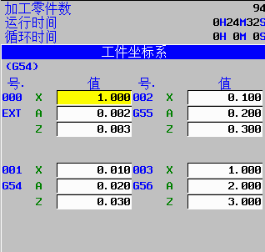
class Program
{
static void Main(string[] args)
{
ushort Flibhndl = 0;

short ret; // 返回值

// 获取库句柄 ( Ethernet )
ret = Focas1.cnc_allclibhndl3("192.168.0.224", 8193, 10, out Flibhndl);
if (ret != Focas1.EW_OK)
{
Console.WriteLine("发生异常，请检查！");
return;
}

#region cnc_rdzofs

short number = 1;
short axis = 1;
short length = 100;
Focas1.IODBZOFS zofs = new Focas1.IODBZOFS();
ret = Focas1.cnc_rdzofs(Flibhndl, number, axis, length, zofs);
Console.WriteLine(double.Parse(zofs.data[0].ToString()) / 1000);//31iA系统，读出结果为：0.01
#endregion
}
}

